Expt 3 Date: /08/2026
Strassen’s Matrix Multiplication

Aim: Implement Strassen’s Matrix Multiplication and compare it with standard matrix multiplication.
Theory:

Matrix Multiplication
Given two matrices A and B, where:
- A is an n × n matrix.
- B is an n × n matrix.
Their product is a matrix C = A × B, where each element is calculated as:
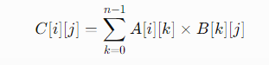
Standard Matrix Multiplication

The standard method uses three nested loops.

For every element of the result matrix, a row of matrix A is multiplied with a column of matrix B.

Algorithm:
For i = 0 to n-1
For j = 0 to n-1
Set C[i][j] = 0
For k = 0 to n-1
C[i][j] = C[i][j] + A[i][k] × B[k][j]
Time Complexity

There are three nested loops, each running approximately n times.

Therefore, the standard matrix multiplication algorithm has:
Time Complexity = O(n³)
Strassen’s Matrix Multiplication
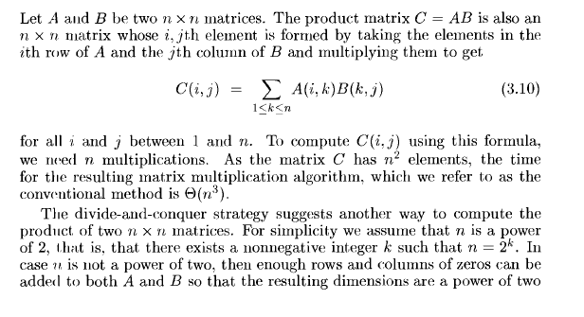
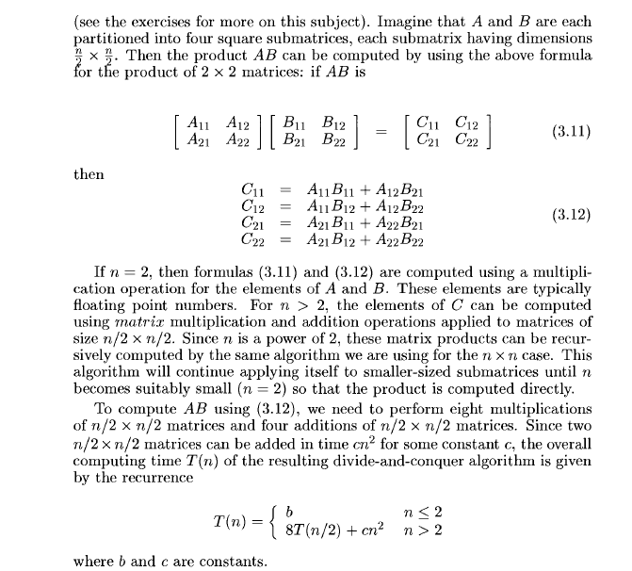

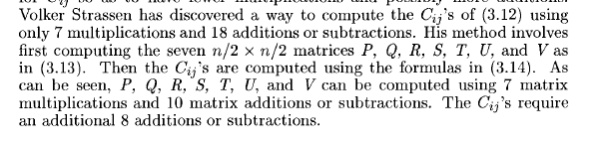
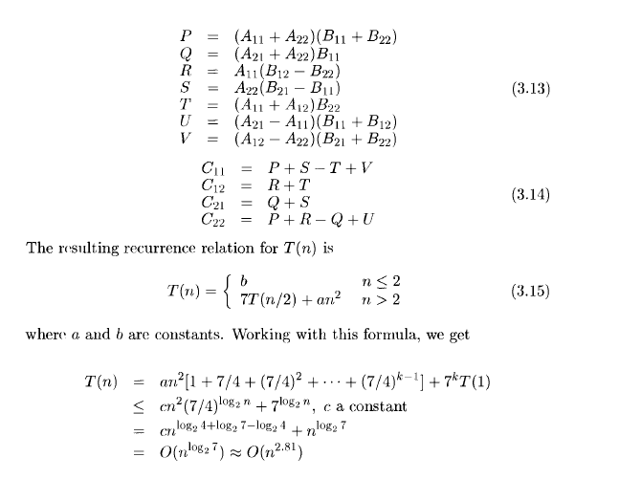
Steps to perform:
Standard Matrix Multiplication
Input: Two 2×2 matrices A and B
Output: Product matrix C

Start
Read the elements of matrices A and B.
Initialize the result matrix C with zeros.
For i = 0 to 1:
For j = 0 to 1:
For k = 0 to 1:
Calculate
C[i][j] = C[i][j] + A[i][k] × B[k][j]
Display the resultant matrix C.
Record the execution time.
Stop
Steps:
Strassen’s Matrix Multiplication
Input: Two 2×2 matrices A and B
Output: Product matrix C
- Start
- Read the elements of matrices A and B.
- Let
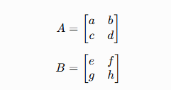

4.Calculate the seven intermediate products:
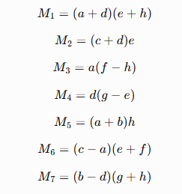
5.Calculate the elements of the resultant matrix:
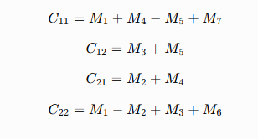
6.Form the resultant matrix:
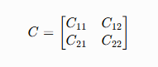
7.Display the resultant matrix C.
8.Record the execution time.
9.Compare the execution time with Standard Matrix Multiplication.
10.Stop

Task : implement Strassen’s Matrix Multiplication and Standard Matrix Multiplication for 2×2 matrices, and compare their performance based on execution time.
- To implement standard matrix multiplication for a 2×2 matrix.
- To implement Strassen’s matrix multiplication for a 2×2 matrix.
- To calculate the execution time of both methods.
- To compare the execution time of the two.

Code:

Output:

Conclusion:

